**COP3809C: Lab Assignment 1 Structure Programming**

**(10 points)**

This lab assignment, you will practice and review the structure or modular programming concept.

**Task 1: Guess Numbers**

For task 1 in this lab assignment, you will create program for guessing the random number from 1 to 100 game. First, the program must generate the random number between 1 to 100 using library and commands that are provided in the lab. The player should enter the guess number on console. If guess number equals random number, the program will be stop and display the player win as shown in:

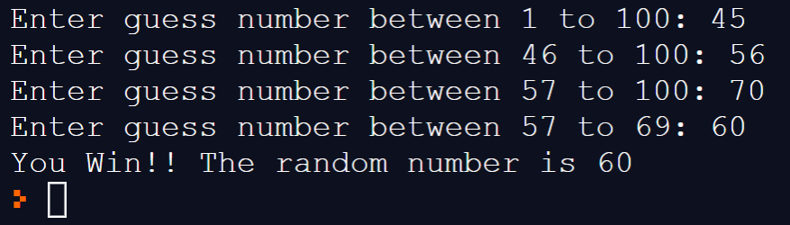

If the player cannot guess the random number, the program should display message the player is lose and show the correct random number as shown in:

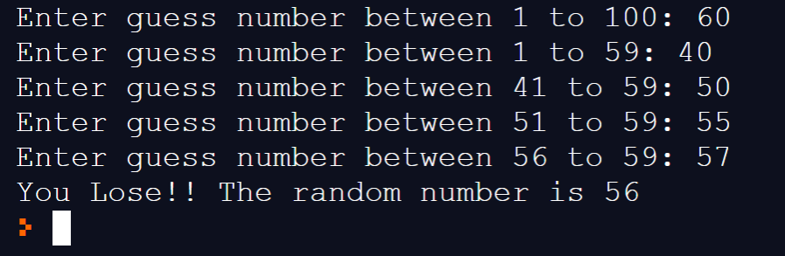

The program should guide player enters appropriate number. If the player enters the number that is not in the range. The program MUST detect the error and let player to reenter the guess number again as show in:

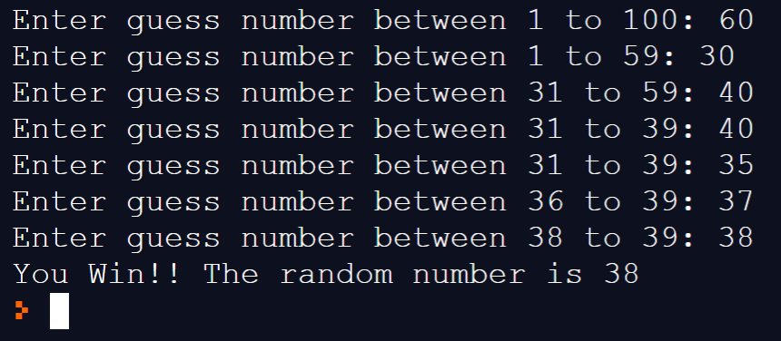

After finishing task1, you can submit the java file name as “Lab1GuessNumber_XXXX.java” where XXXX is your student id.

**Task 2: Bars 21**

This task, you will create game Bars 21 or Sticks 21. There are 21 Bars and two players (A and B) in this game. The program must randomly select who is the first player (A or B). Each player can pick up the bars or sticks only 1, 2 or 3. The player who picks up the last bar(s) will loss in the game.

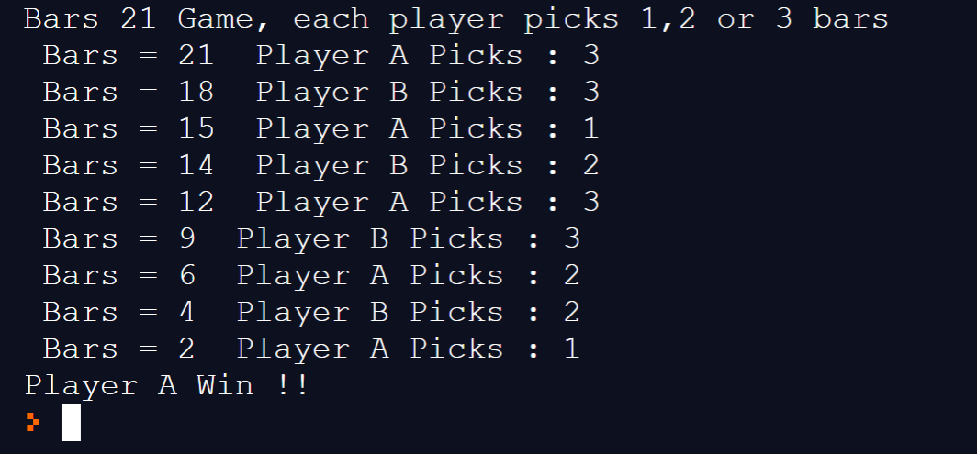

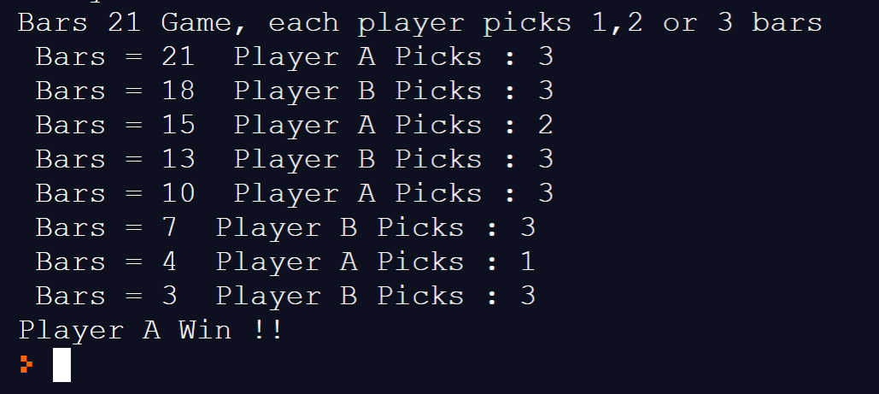

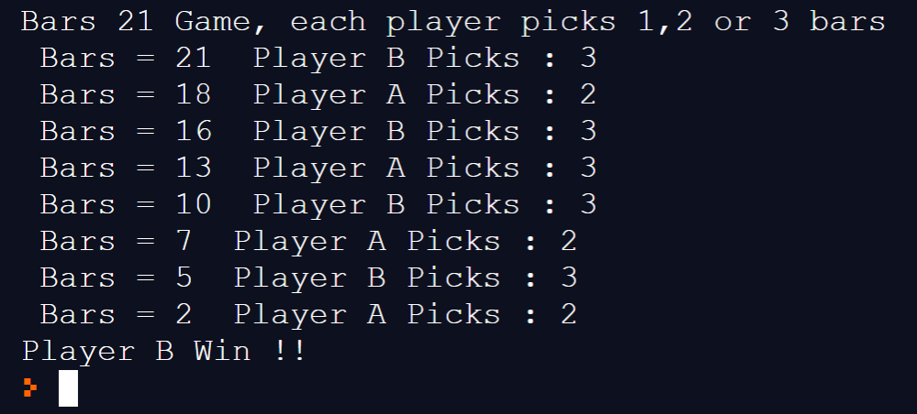

The program MUST detect the error and let player to pick the appropriate number of bars(sticks) as shown in:

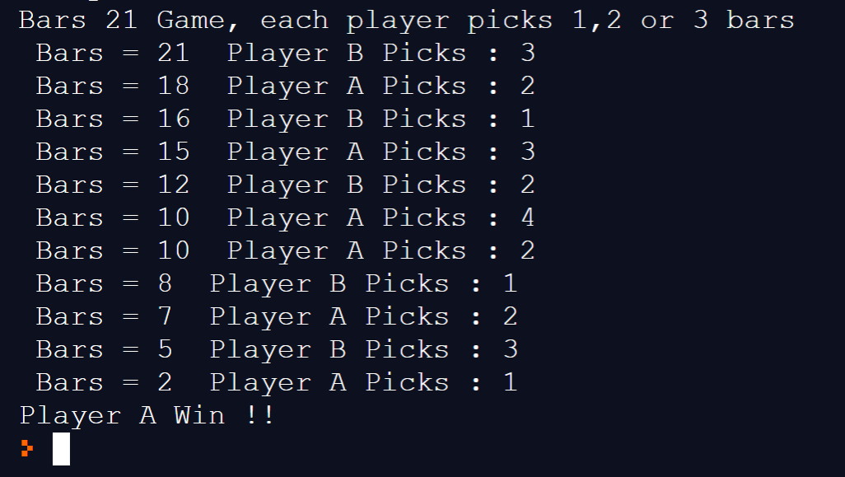

After finishing task2, you can submit the java file name as “Lab1Bars21_XXXX.java” where XXXX is your student id.

After completing the lab assignment, zip up two files (Lab1GuessNumber_XXXX.java, Lab1Bars21_XXXX.java) under Lab1 folder, the name of the zip must be “COP3809_LAB1_SXX_YYYY.zip” where XX is your section 01,02 or 03 and YYYY is your student id. And submit zip file in Canvas.